POBA Medical Senior Capstone Project

Operations Manual

Anthony Peters
Shane Pooler
Ryan Stevenson
Kevin White

April 20, 2018

Project Sponsor: POBA Medical
Instructor: David Trevas

Introduction 3
CAD Model 3
Assembly 4
Frame 4
Camera System 6
Rotary System 9
Air System 11
Maintenance 14
Cleaning 14
Operation 14
Appendix 15

Introduction
The scope of this document is to instruct on how to assemble, maintain, and operate the automated balloon catheter inspection device. The assembly section includes how the device is properly put together. The maintenance section covers instructions on how to maintain the device to ensure consistent catheter balloon measurements. The operation section includes how to safely and correctly operate the device.

CAD Model

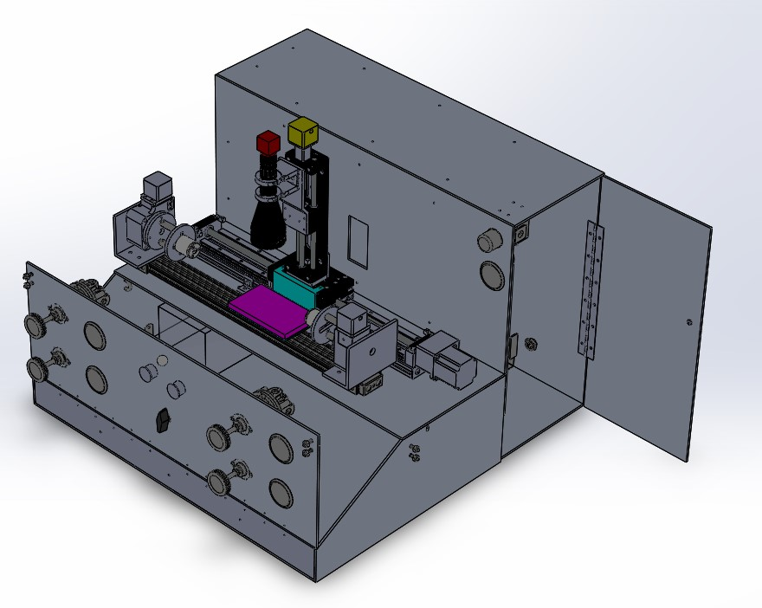
Figure 1: Complete CAD model of the machine

Assembly
This section will cover how to build the machine starting with everything completely disassembled. The device has four subsets that when put together, create the final device. All the subsets are broken up and have step-by-step instructions to properly assemble each.

Frame
The image below details the how the frame is assembled. The frame parts are labeled 1 through 11 with the brackets, hinges, loops, and ball knobs labeled B,H,L,K, respectively. The frame features tapped holes so that the screws do not need nuts on the other end.
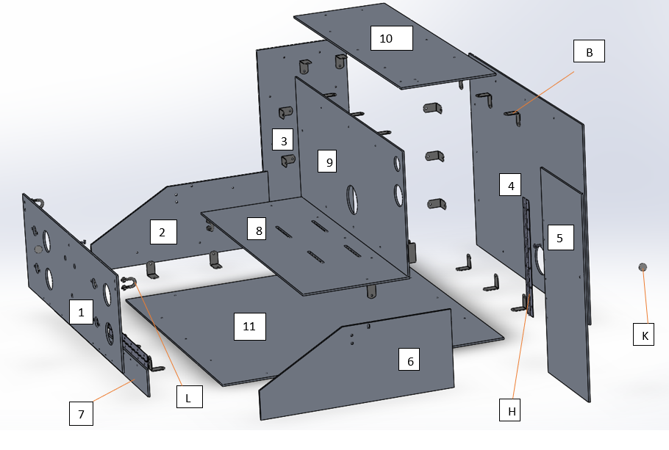
Figure 2: Exploded View of Frame

- The brackets use a 10-32 phillips head screw to mount to the frame parts
- The hinges use a 6-32 phillips head screw to mount to frame pieces 1 and 5
- The ball knobs are fastened together with a 10-32 screw
- The loops come with a ¼-20 nut to fasten them together.

Part | Designation | # of pieces
Frame | 1-11 | 11
Ball Knob | K | 2
Hinge | H | 3
Bracket | B | 33
Loops | L | 4
Frame screw | 10-32 | 33
Hinge screw | 6-32 | 36

Camera System
This section provides assembly instructions for the camera system. Table 1 outlines each part used for this sub-assembly, the part quantity, and part vender.

Table 1: Camera System Parts
Vendor | Part | Location on device (see figures 3) | Quantity
Cognex | In-Sight 5100 | 1 | 1
Edmund Optics | x0.16 Telecentric Lens | 2 | 1
Edmund Optics | 3.5" x 6" White, LED Backlight | 3 | 1
Newmark | Linear D-slide stage (400mm) | 4 | 1
Newmark | E-Track Z-Slide stage (150 mm) | 5 | 1
Newmark | L-Bracket | 6 | 1
3D Printed | Lens Mount | 7 | 1
3D Printed | Adaptor Plate | 8 | 1
3D Printed | Left Backlight Bracket | 9 | 1
3D Printed | Right Backlight Bracket | 10 | 1
Cognex | PoE Cable | 11 | 1
Cognex | 24VDC cable |  | 1
Cognex | Etherbus |  | 1
 | Ethernet cable |  | 1
 | 24V cable |  | 2
 | Computer |  | 1
Cognex | InSight Explorer Software |  | 1

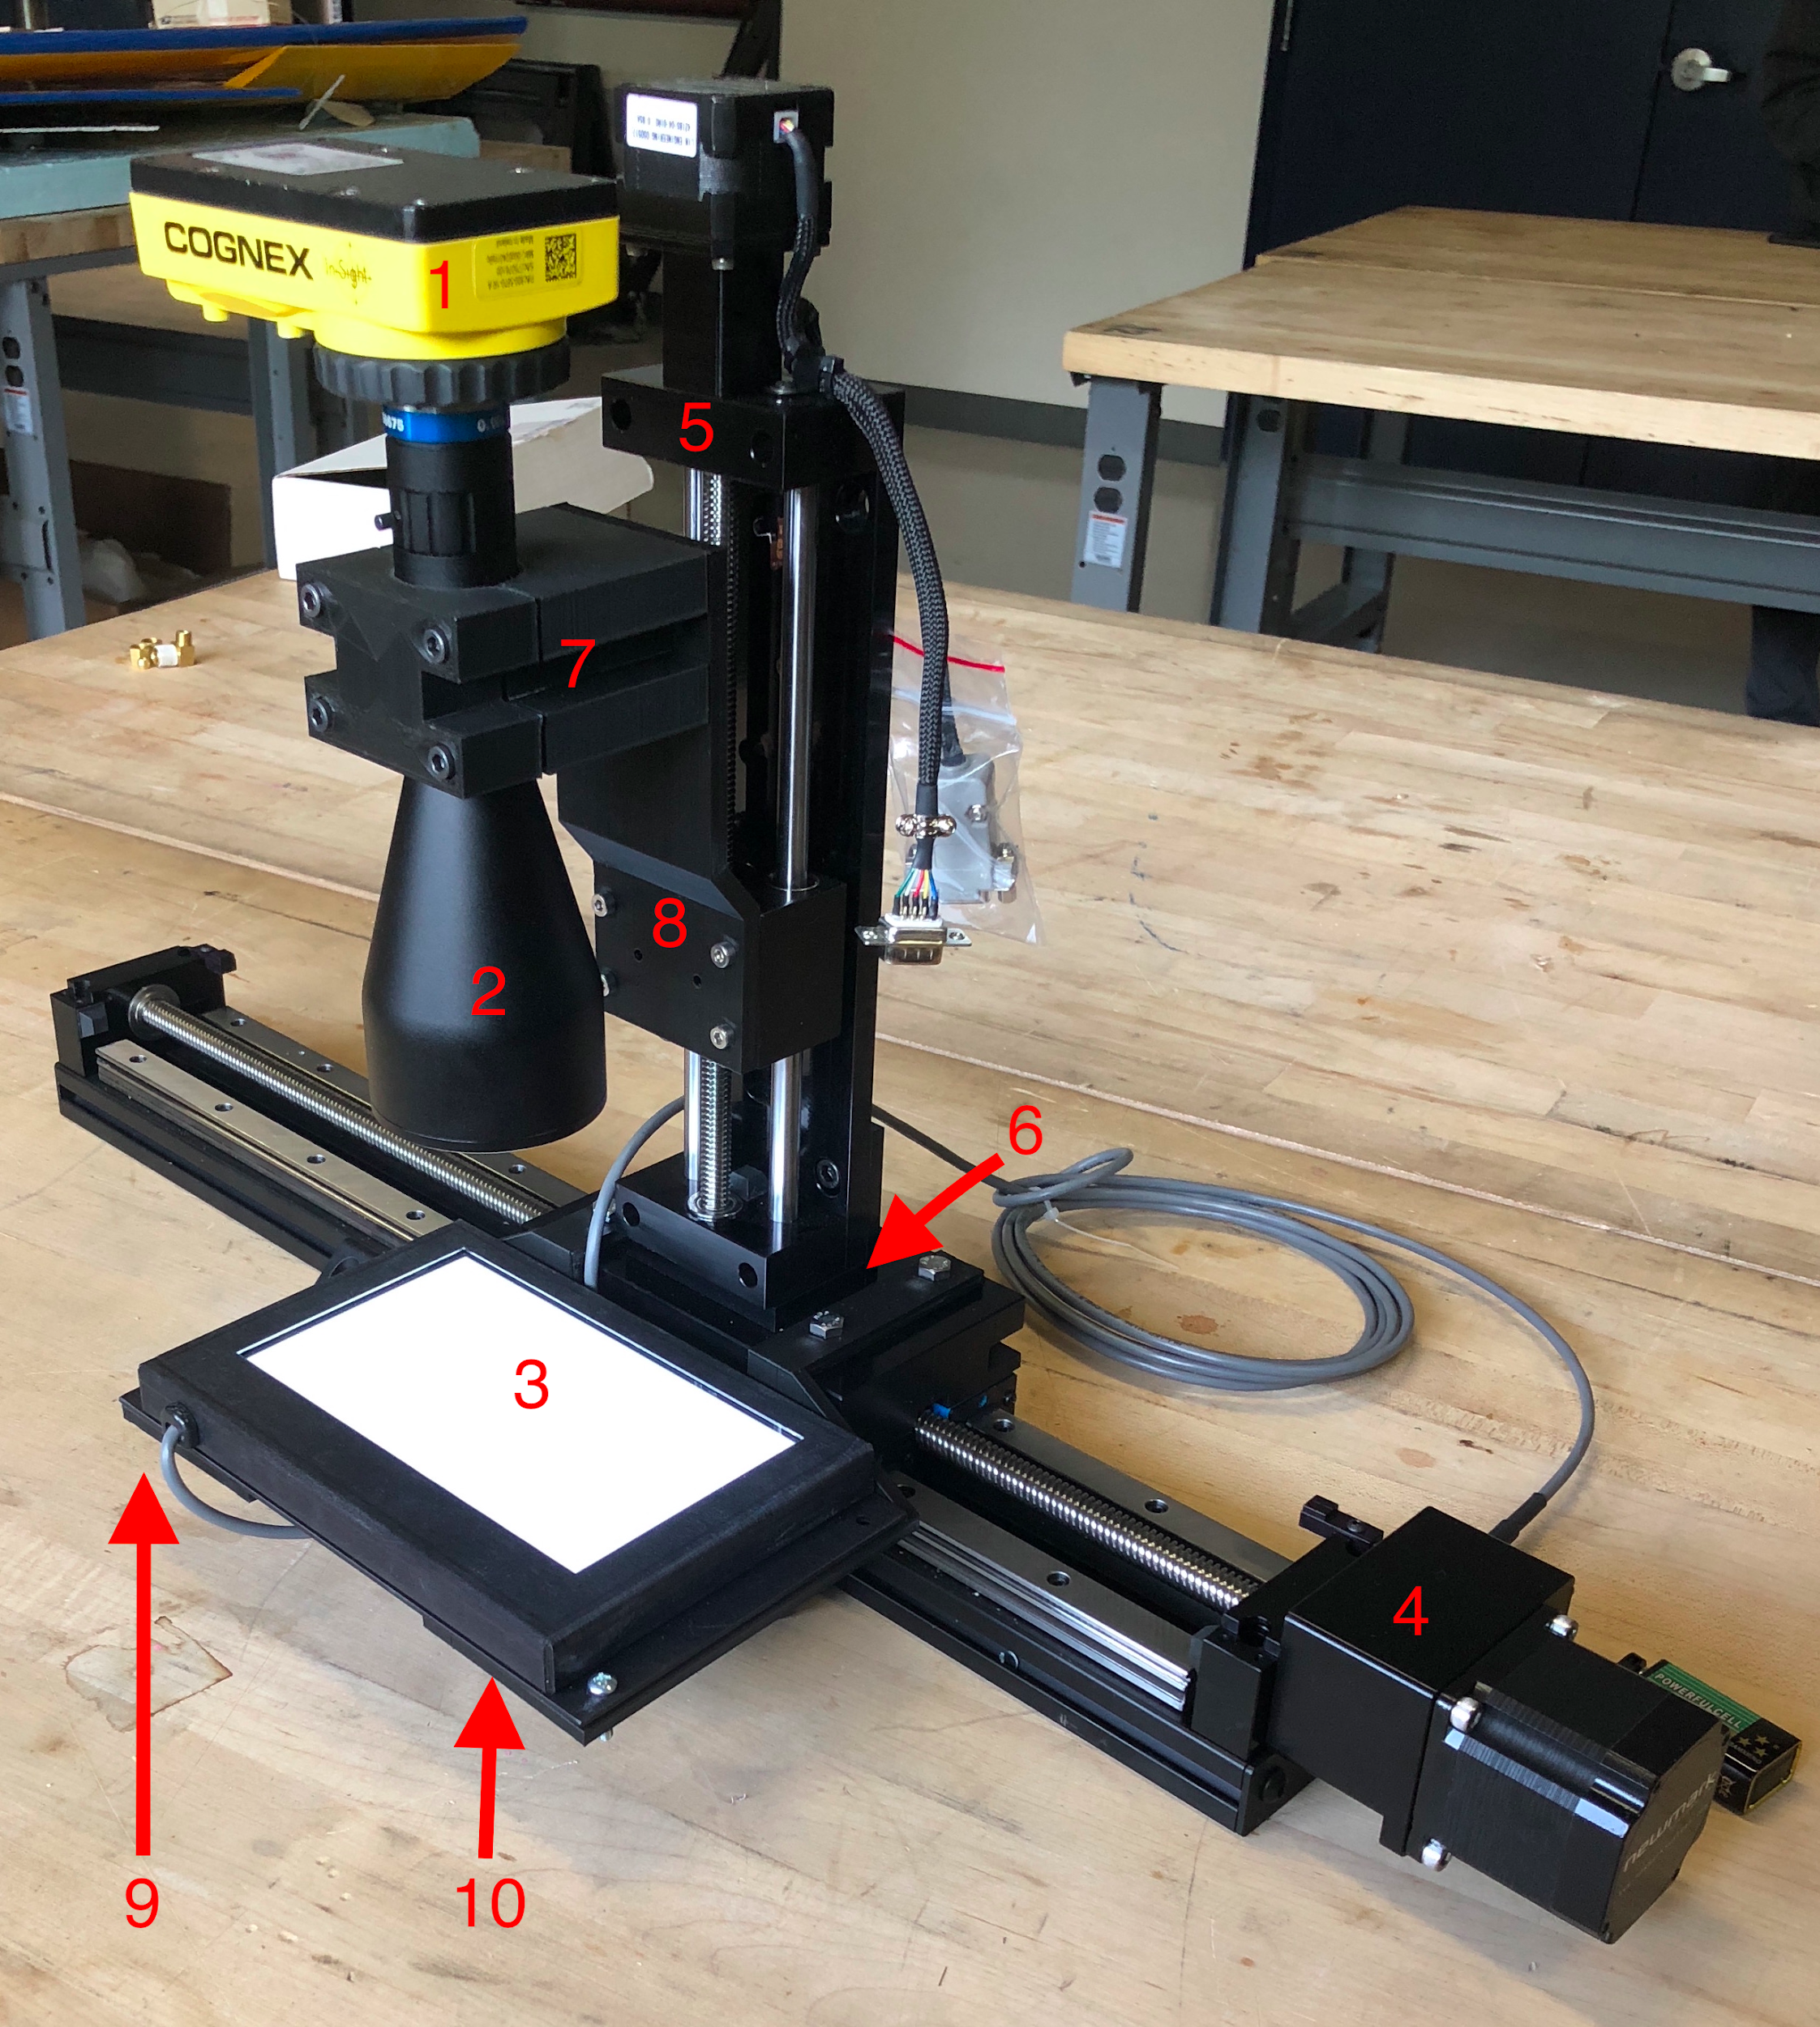
Figure 3: Camera system with part location.

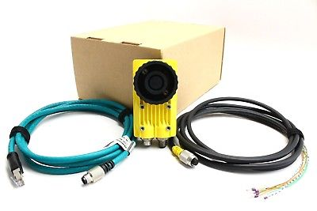
Figure 4: Camera with PoE cable and 24VDC cable.

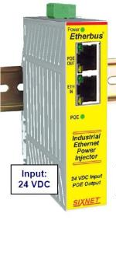
Figure 5: Etherbus

Steps to assemble Camera System:
- Attached Newmark Linear D-slide stage to frame.
  - Use ¼-20 screws.

- Attached Newmark L-Bracket to Newmark Linear D-slide stage and mount Newmark E-Track Z-Slide stage to bracket.
  - Attach L-Bracket to D-slide stage with given screws.
  - Attach E-Track Z-Slide stage to L-Bracket with given screws.

- Align and attach adaptor plate to Newmark E-Track Z-Slide.

- Assemble Cognex Camera and the Edmund Optics x0.16 Telecentric Lens. Simply remove the cap on the Cognex Camera and screw on to the top of the lens.

- Place Lens in between lens mount. Tighten accordingly.
  - Use 1/4-20 screws to attach Lens Mount together.

- Attach Lens Mount to adaptor plate.
  - Use1/4-20 screws.

- Attach Backlight to D-Slide stage.
  - Attach left and right 3D printed backlight brackets to D-Slide stage.
  - Align screw holes on backlight and 3D printed brackets.
  - Secure with 4 screws and 4 nuts

- Plug in ethernet cable and 24VDC power cable to camera.
- Connect the the 24VDC cable to the 24V power source.
  - The green and white wire is the positive and the loose silver wires are the ground.
- Attach second 24VDC cable to Etherbus.
  - The two center slots on the back of the Etherbus (green box) is designated for the positive and ground wires of power source to be inserted.

- Connect PoE cable to PoE slot on the Etherbus.

- Connect ethernet cable to ETH IN slot on the Etherbus and the other side into a computer that supports InSight Explorer program.

- Launch InSight Explorer.

Rotary System
This section provides detailed assembly instructions for the rotational system. This sub-assembly includes:

Table 2: Rotary System Parts
Vendor | Part | Location on device (see Figure 5) | Qty
Newmark Systems | RM-3 Rotary Stage | 1 | 2
Blockwise | CCB Tube Grabber | 2 | 2
McMaster | T-Slotted Framing (29 inch) | 3 | 1
McMaster | Sleeve bearing carriages | 4 | 2
McMaster | Threaded end caps | 5 | 2
McMaster | Male-Female Pillar Posts | 6 | 4
3D printed | L-mount | 7 | 2
3D printed | Tube Grabber disk mount | 8 | 2
3D printed | Rotary stage disk mount | 9 | 2
3D printed | Frame mount | 10 | 2
McMaster | End-feed fasteners | 11 | 2

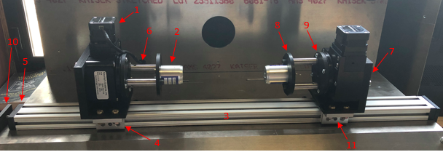
Figure 5: Rotary System with part location

Steps to assemble Rotary System:
- Attach Newmark RM-3 Rotary Stage to custom L-mount.
- Use (3) #8-32 machine screws and attach nut to ends
- Attach custom rotary stage disk mount to face of RM-3 Rotary Stage.
- Use (4) #8-32 machine screws
- Attach the male end of the Male-Female Pillar Posts to custom rotary stage disk mount.
- Use (2) #8-32 tapped holes
- Attach custom tube grabber disk mount to female end of Male-Female Pillar Posts.
- Use (2) ¼”-20 machine screws
- Attach Blockwise CCB Tube Grabber to custom tube grabber disk mount.
  - Use (2) #10-32 machine screws
- Attach assembled parts Step 1-5 to sleeve bearing carriage.
  - Use (4) ¼”-20 machine screws and attach nut to end
- Attach assembled parts Steps 1-6 to T-slotted framing slide (29 inch).
  - Attach ¼”-20 end feed fasteners to secure rotary stages to slide
- Attach T-Slotted Framing slide (29 inch) with assembled parts to frame.
- Attach threaded end cap to T-slotted framing (29 inch)
- Attach custom frame mount to threaded end cap using (1) ¼”-20 screw
- Attach custom frame mount to frame using (1) ¼”-20 screw and nut

*Note: Complete Steps 1-6 for twice for full assembly

Air System
The air system is comprised of a bunch of parts that are all connected using nylon tubing. The nylon tubing attaches to each component with the use of hose couplings.
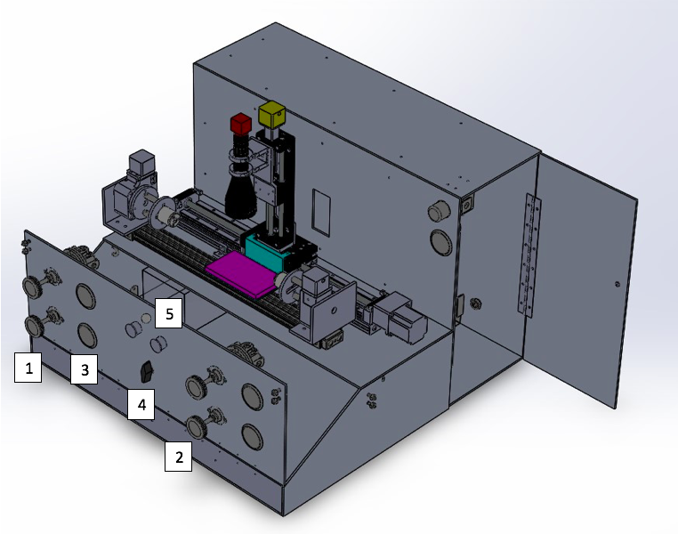

Table 3: Air System Parts
Part | Location in Manual | Label | Qty
Hose coupling | Appendix A (Figure B) | 1 | 1
Air regulator (5-400 psi) | Figure 6 (1) | 2 | 1
Air regulator (5-150 psi) | Figure 6 (2) | 3 | 1
0.25” Nylon Tubing |  | 4 | 1
¼” Tee Connector | Appendix A (Figure C) | 5 | 10
Pressure Gauge (0-400psi) | Figure 6 (3) | 6 | 1
Directional Control Valve | Figure 6 (4) | 7 | 1
Through-wall adapter 1/4" | Appendix A (Figure A) | 8 | 1
Balloon Tubing 1/8" ID 1/4" OD |  | 9 | 1
1/8" Tubing for Bladder (10ft) |  | 10 | 10 ft
Buttons for bladder | Figure 6 (5) | 11

- Screw on middle part of tee connector into each pressure gauge
- Attach hose couplings to all of the following components
  - Regulators
  - Gauges
    - Hose coupling will go onto each side of the t-valve
  - On and off valves
  - Air tank
- Use screws (2) and fasteners (2) to attach the following onto the front part of the frame
  - Regulators
- Attach onto the front frame by slipping in from the front
  - Gauges
  - Buttons for the bladder
- Install air hose into air tank couplings
  - Make sure this tubing is long enough to go from the air tank to the valve that goes between the high and low pressure sides
  - ¼” one one side and ⅛” on the other
- Attach tubing to this valve
- Cut another section of this tubing that will connect the top output of this valve to the pressure regulator
  - Use ¼” tubing since this is the tubing being used for the air pressures
- Cut another piece of ¼” tubing long enough to go from the regulator to the gauge
- The next piece of ¼” tubing will go from this gauge to one of the two inputs of the manual valve that control which air pressure goes into the balloon
- Go back to the valve that separates into the high and low pressure side
- Cut a small section of ¼” tubing that goes from the last port in this valve to a t-valve
- The top part of this t-valve will be set up the same way as steps 6-8
- The bottom part of the t-valve will use a piece of ⅛” tubing
- Attach this ⅛” tubing to the tube grabbers for the balloon
- Connect a piece of ⅛” tubing from the output of the on and off valve at the end of the air system to the balloon that is on top of the frame

Maintenance
This section will cover the cleaning and operation process for the automated balloon catheter inspection device.

Cleaning
Before operation the entire exterior of the device is to be wiped down using 70/30 Isopropyl Alcohol and lint free wipes.

Operation
- Turn on computer
- Adjust rotary stages for correct length and input balloon using the on/off valves located on the front panel.
- Adjust eTrack (z stage) for optimal height
- Adjust air flow to indicate low or high pressure
- Begin procedure of measuring balloon using the computer
- Uninstall balloon.

Appendix
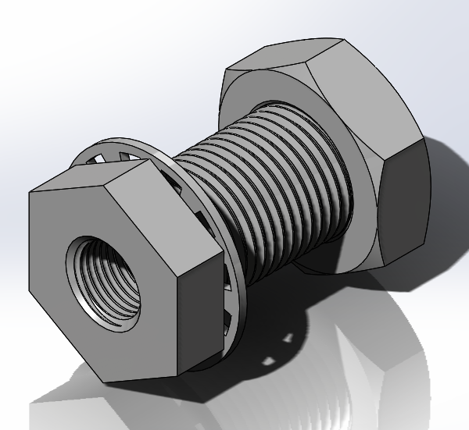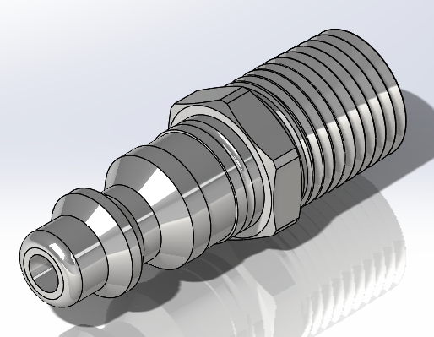
Figure A Figure B
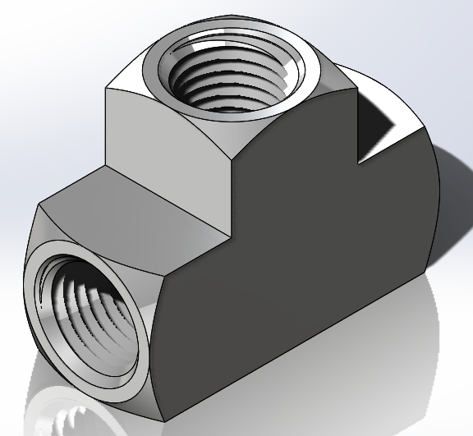
Figure C

